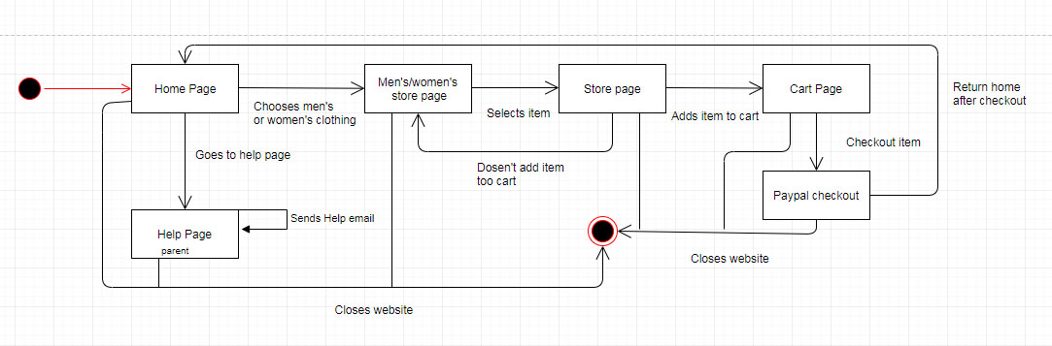**Volume Web store Design Document**

https://www.bene.be/blog/comments/a_webdesign_brief_document_for_every_website

**Introduction**

This document will outline our design for the Volume-inc Webpage, we will talk about our goals for the website as well as the overall design of the site.

**Project Milestones**

There are a few different milestones along the course of building the site, the first one will be the completion of the front page. This will lay the ground work for every other page as we will be using elements such as the nav bar throughout all the pages of the website.

Once we have completed the front page we will have the basics for the rest of the pages, however another milestone at this point will be the database. Once the database is finished and populated we will be able to start putting items onto the store pages.

Add more milestones

**Target Audience**

The target audience for the site would be similar to ourselves, 18-30 men and women who generally shop at places like END, Size or JD. We believe we understand what this audience likes and can create something that would appeal to this demographic.

**Design**

**Coloures**

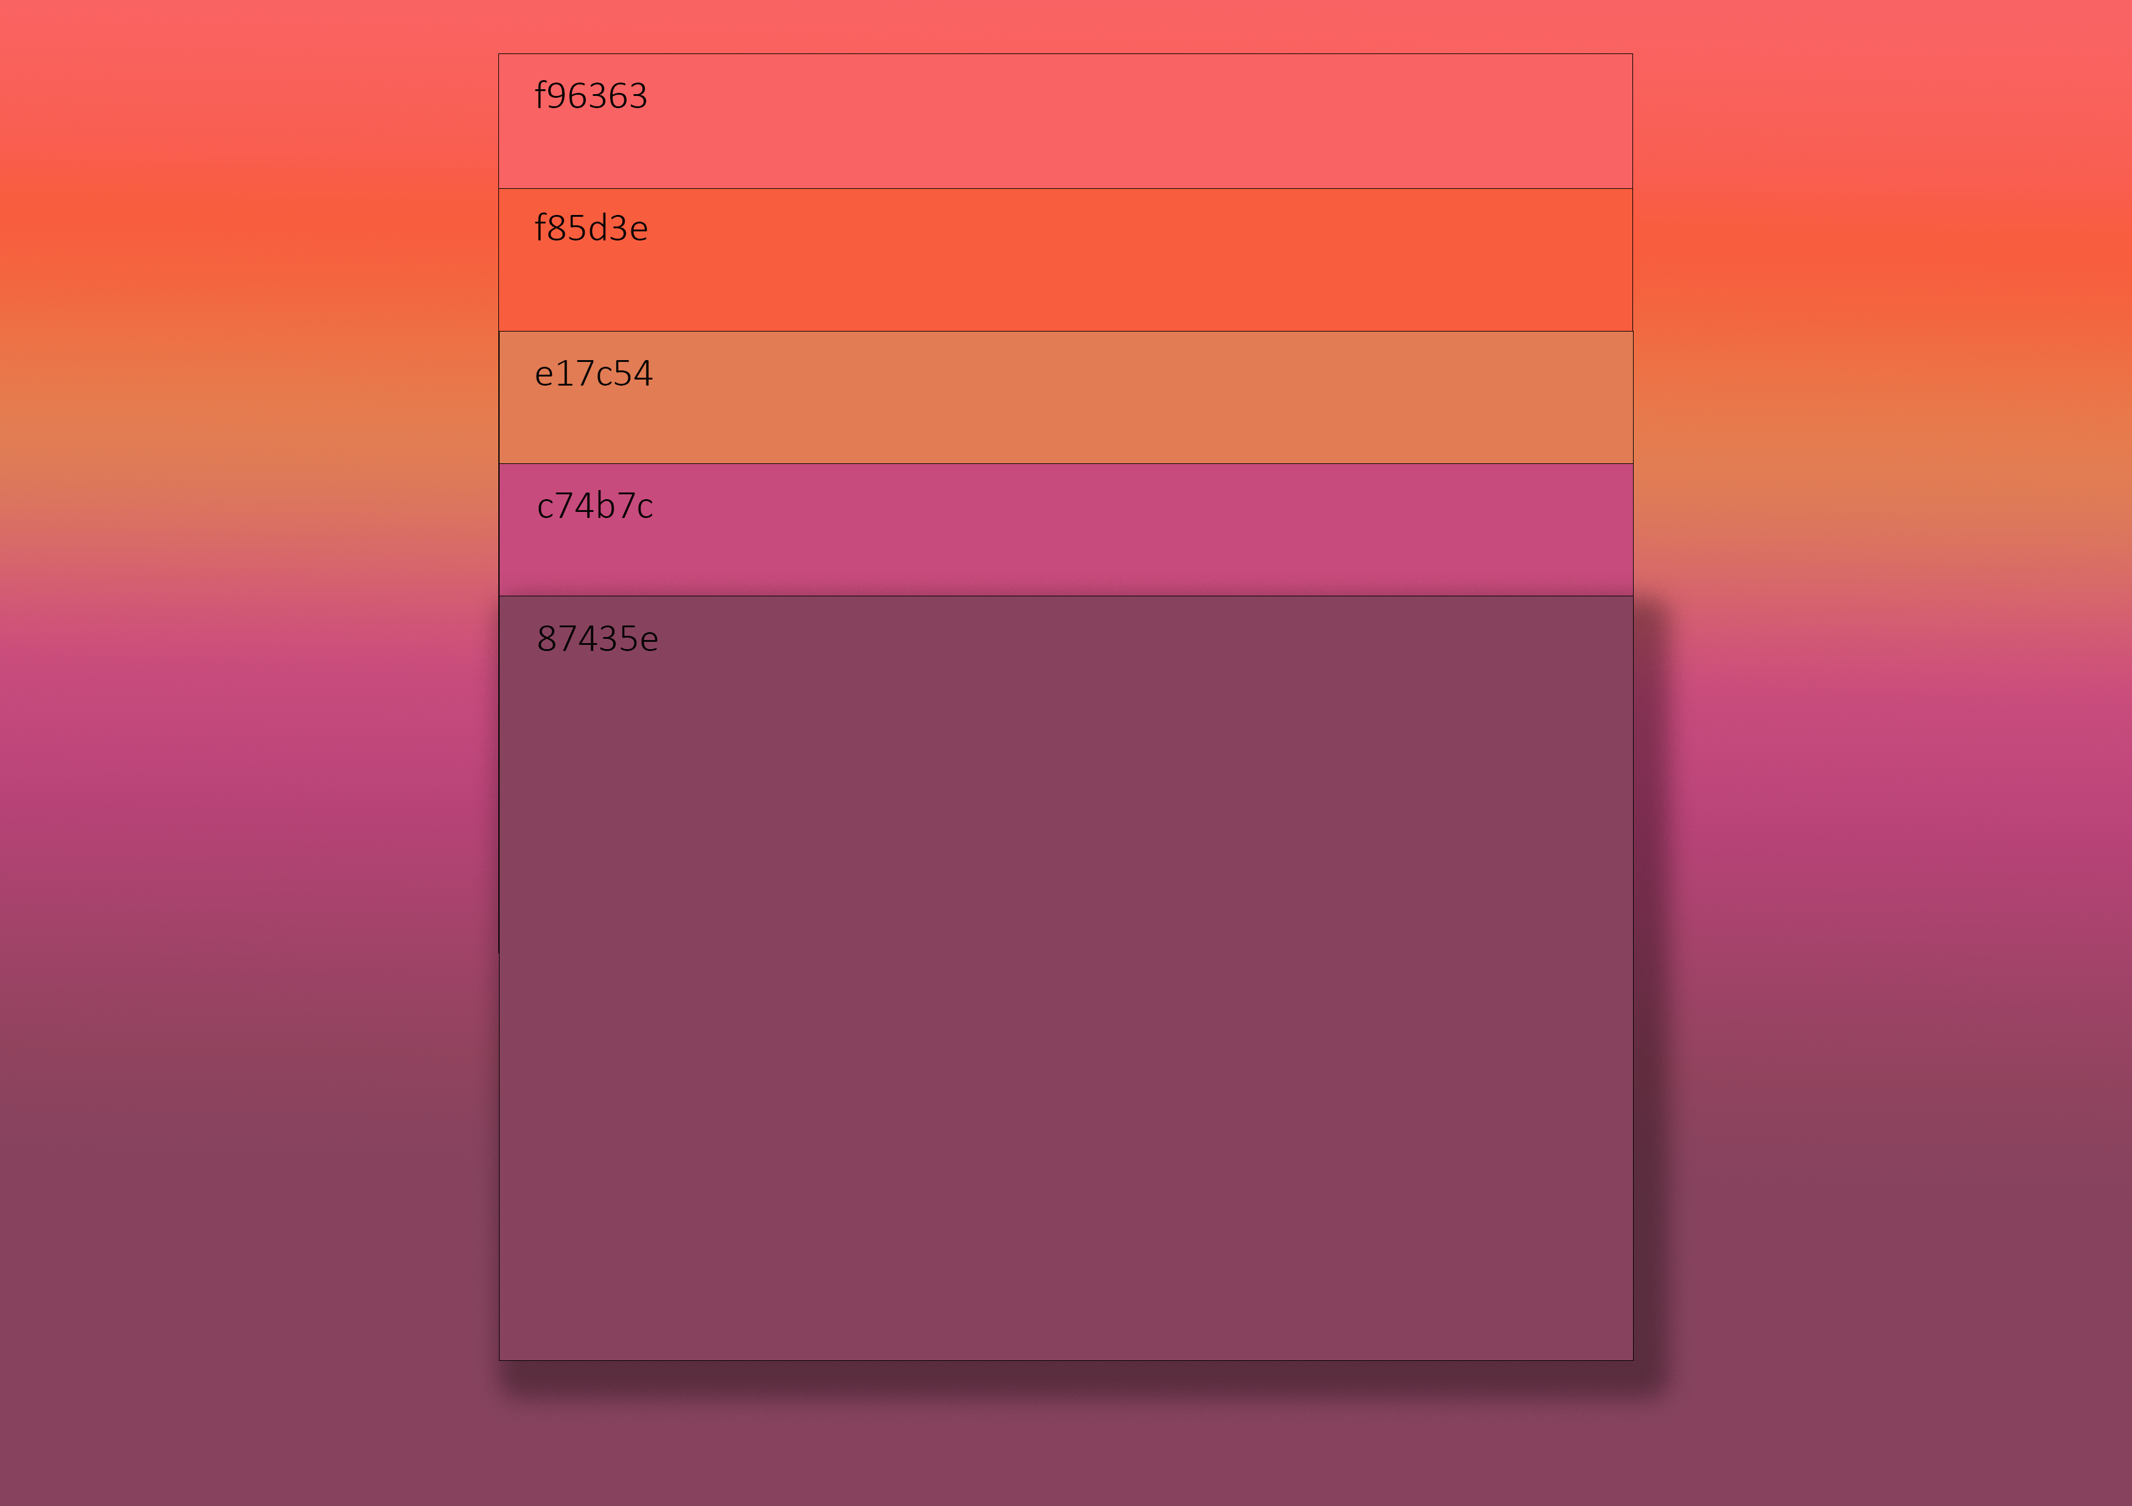

**Logo**



Logo was created by Aows to be simple as we are trying to emulate the minimalist style that is currently very popular with the demographic we are aiming at.

**Font**

**Lay-out**

The state dia

gram above shows the standard user interactions with the website,

**Front Page**

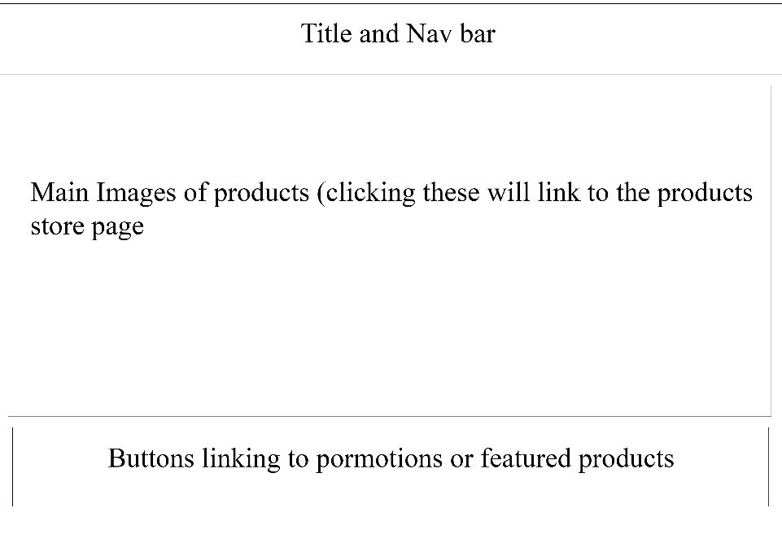

**Mobile Front page**

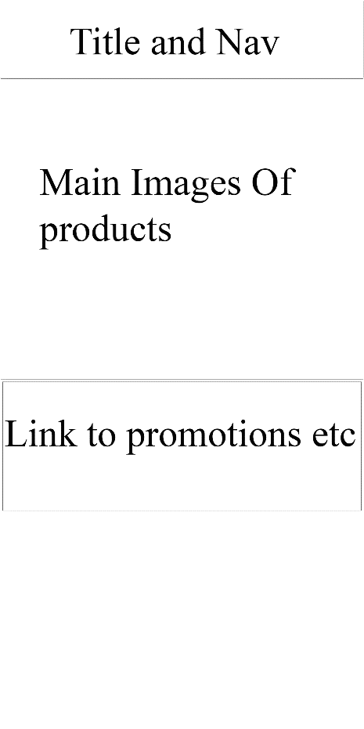

**Store Page**

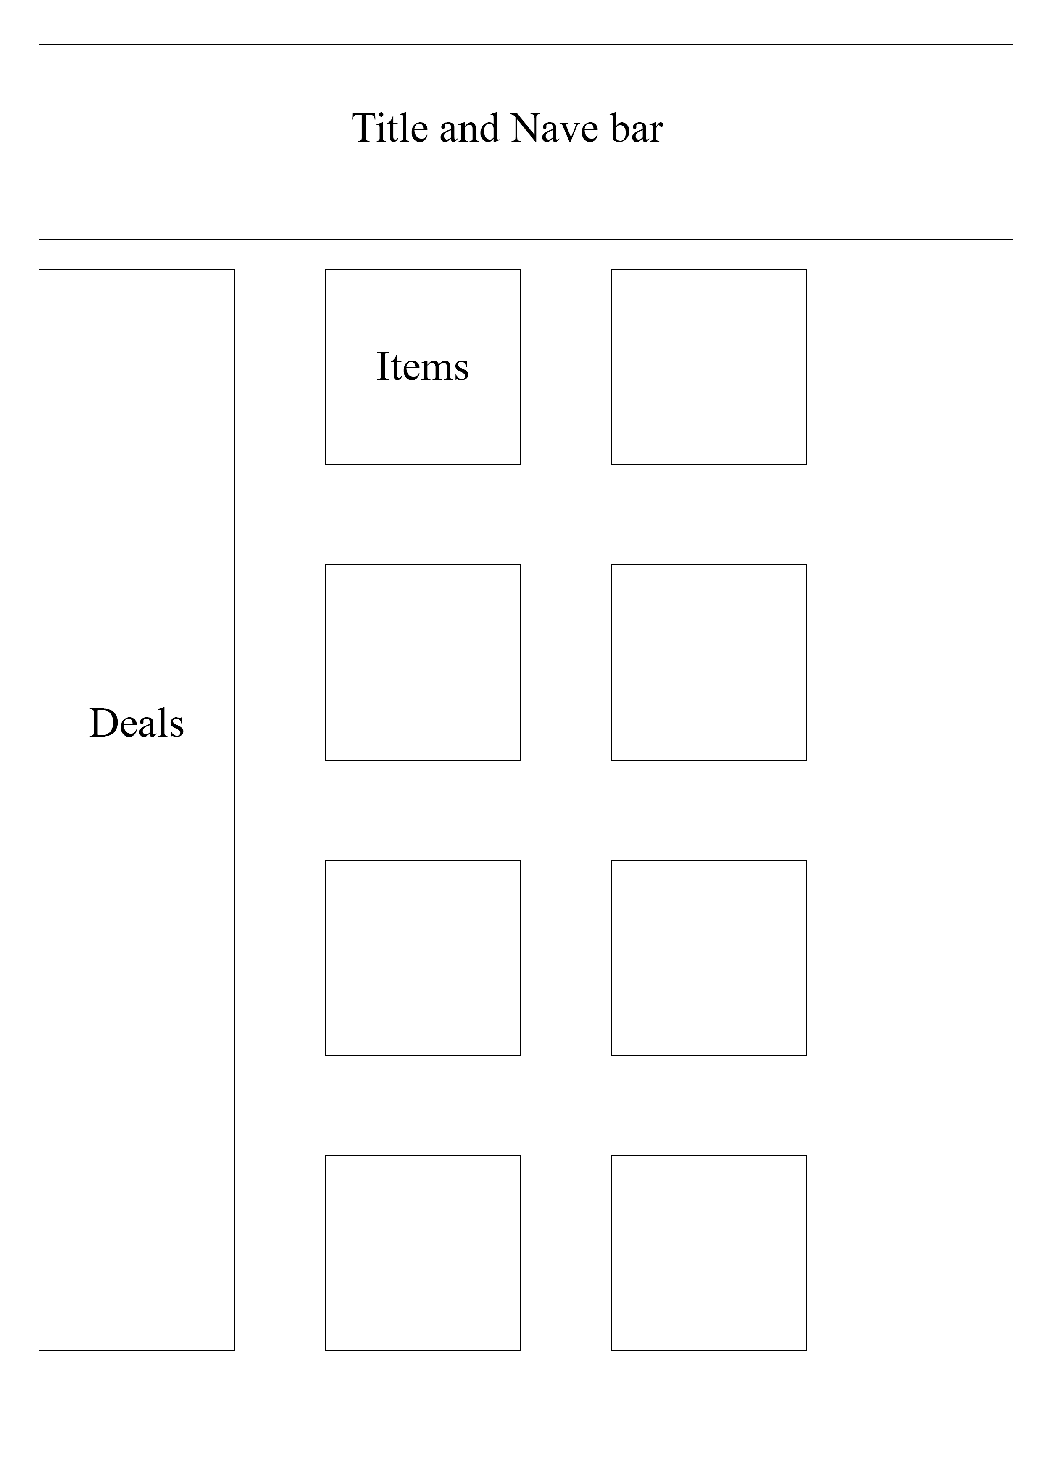

These are the basic layouts we will be using for our divs for the various pages, these layouts are taken from our research of other websites we are trying to emulate.

**Interactive elements**

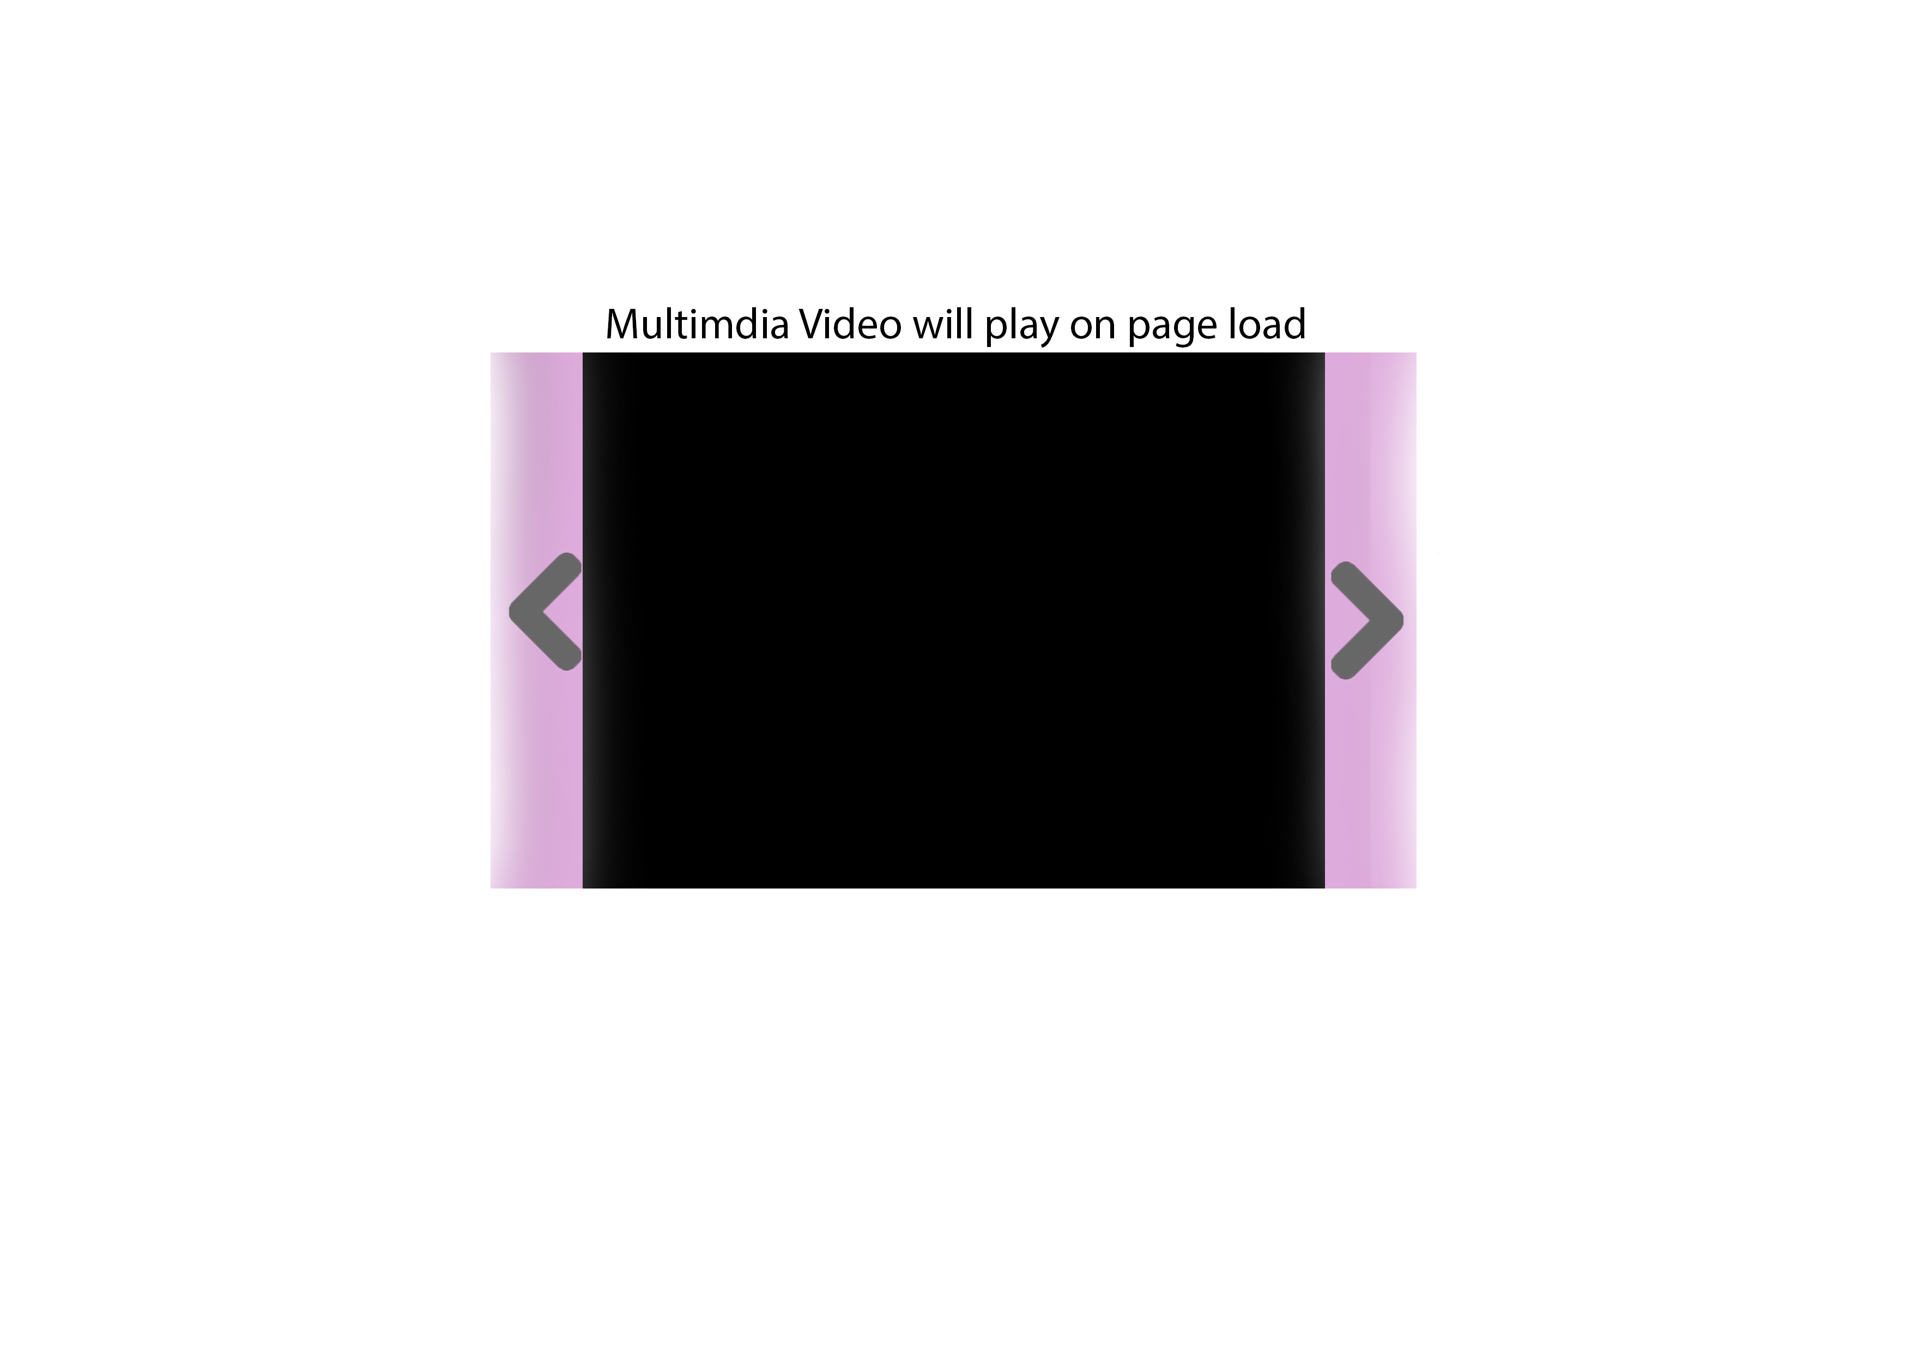

The first slide of the slideshow will be a custom made video, this will add some extra quality to the website making it much more appealing and professional looking. We want the user to see our website and think that it looks well-made therefor the products we are selling must also be high quality.

Additionally we think it will engage users more than just a static image and make the site stick in their mind more making them more likely to return to the site in the future.

We will have to keep in mind that a HD video may not be suitable for a mobile site because of data usage problems. To tackle this we will keep the video limited to desktop and tablet versions of the site and use a static image for the mobile site in order to better optimize for those users.

**Example Sites**

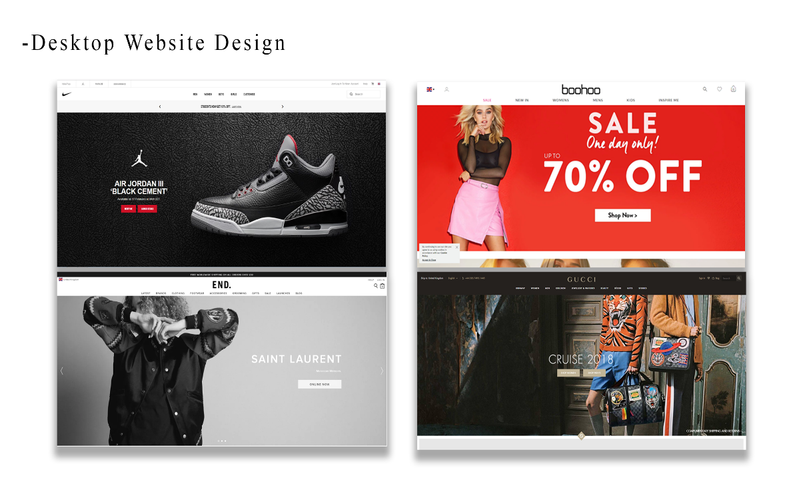

Above are examples of sites we are going to try and emulate, there are a few common themes from these sites that we have tried to incorprate into our design. The main viewport is taken up by a slideshow that mvoes through things such as new products and offers. The nav bar sits at the top of the screen , this is it for the fron page of some sites however others scroll down and show links to specific new items.

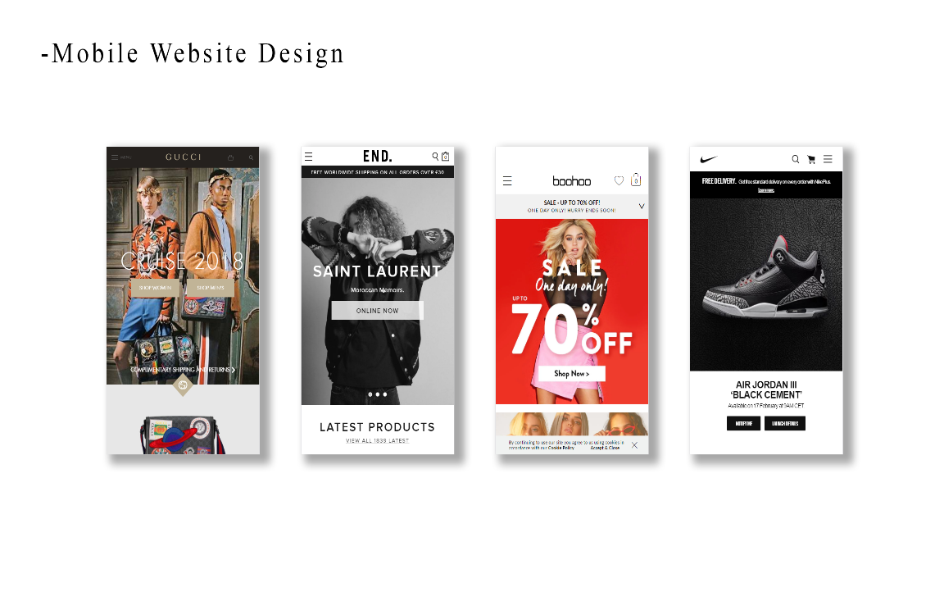

Above are the mobile versions of the sites, they very clearly try to keep the viewport similar to the desktop version. They generally move the Nav bar into a drop down ‘burger menu’, and then have additional links as you scroll down the page.

**Structure**